How Facility Managers Improve
Triple Bottom Lines

A White Paper For Leveraging Onsite Refurbishment

Prepared for PROTEK by David Ableman

Before After
Wooden:
Tables,
Desks, Credenzas, Floors, etc.

Leather:
Chairs,
Couches,
Table Tops, etc.

Upholstered Fabrics:
Chairs,
Couches, Cubicles,
Walls, etc.
Executive Summary
Underutilized and unappreciated, refurbishing fills a gap during furnishing lifecycles
This white paper documents how Facility Management (FM) can cut costs while promoting sustainability, increasing employee productivity and revenues, improving facility appearances, decreasing absenteeism, and extending the useful life and lifetime value of furnishings.…all with one underutilized service, onsite refurbishing.

Everyone knows preventive maintenance can reduce the likelihood of costly and disruptive problems. Similarly, refurbishing is fundamentally the most cost-effective method for extending the useful life and value of furnishings. In addition, when compared with alternatives that would need to be performed offsite, onsite refurbishing services are the least intrusive when performed on weekends, or after hours. This is especially true when provided by a company that uses products and processes that are odorless and EPA as well as OSHA approved for indoor purposes.
An ounce of prevention is worth a pound of cure
Why is refurbishing unappreciated? Because it is not well understood! When people hear the word “refurbish,” most naturally think “refinish” or “repair.” The good news is, before appearances become intolerable, informed teams now evaluate refurbishing. When starting to think it may be time to replace, repair, reupholster, or even refinish wood, leather, fabric, or metal furnishings, pause, and think refurbish.

FM Anxieties

- Cost-overruns to maintain facility and furnishing appearances;
- Neglecting sustainability principles, initiatives and policies;
- Lost bonuses resulting from missing tight budget targets;
- Scorn and surprise from Senior Managers who are dissatisfied with facility appearances;
- Using the wrong personnel or contractor on a project which creates costly mistakes that compromise outcomes and budgets. For example, consider: Does in-house personnel have sufficient skillset and core-competencies, with knowledge of best practices, to cost-effectively perform specialized tasks beyond simple touch-up and repair?

Benefits of Refurbishing vs. Alternatives

- Lowest Cost
- Least Disruptive
- Quickest Time to Value
- Aligns Best with Sustainability Initiatives
Definitions

- Refurbish (Onsite): According to www.thefreedictionary.com, refurbish is defined as: “to make clean, bright, or fresh again”. As used herein, refurbishing goes beyond simple touch-up. Refurbishing wood includes deep cleaning, removing scratches, nicks, gouges, discoloration, and preservation with specialized oils. Conditioning leather maintains its suppleness to prevent drying and cracking. And upholstered fabrics require deep cleaning and sanitizing. The end result takes your old and makes it like new, or takes your new and keeps it new.
- Refinish (Offsite): To remove all coatings from the surface and then put on a new coating. Refinishing typically includes removing the surface, as well as any coating, and making color corrections and/or color additions.
- Repair (Offsite): To take something that is damaged, broken, or not working correctly, and return it back to good working condition. Additionally, repair typically includes color correction.
- Reupholster (Offsite): Reupholster with new materials, either upholstered fabrics or leathers. Reupholstering may include new foam and extensive work on the frames.

Comparative Options

When considering potential alternatives, review the graph below to see a high-level Cost and Time-to-Complete comparison. This chart shows how typical scenarios will likely compare. Costs are relative to the replacement cost. The project timeline reflects the number of days a facility is likely to be disrupted by each service. Since furnishings and the damage associated with each unit will be unique, exact costs and project timelines will vary.

Refurbishing costs less and takes less time than alternatives
Figure 1: Comparison of Costs and Time to Complete Projects
reinforcing Sustainability and green Initiatives

A widely cited and accepted definition for sustainability comes from the Brundtland Report (1987): “Sustainable development is development that meets the needs of the present without compromising the ability of future generations to meet their own needs.” Consistent with this approach, the 2011 IFMA Sustainability Guide states: “Processes should be completely implemented to ensure the least negative environmental impact.”

With a focus on the Triple Bottom Line (TBL) of environmental, social, and economic consideration (aka “People, Planet, Profit”), Facility Managers demonstrate their commitment to sustainability by adopting programs and leveraging services that minimize adverse impacts on the indoor and natural environment. While many start by using cleaning products that are environmentally friendly, the long-term approach obligates FM teams to eliminate the disposal of items that can be repurposed. Refurbishing is clearly consistent with sustainability by:

- Extending the useful life of furnishings,
- Decreasing waste and landfill, and
- Reducing demand for new products which would increase demands on finite resources making them less available and/or more expensive for future generations.

Increase in Productivity and revenues
Scientific research has firmly established that office environments influence productivity
Studies have proven how appearances and “Dressing for Success” impact productivity. Similarly, “scientific research has firmly established that the office environment can influence people’s health, well-being, and productivity,” with studies showing that keeping an office looking good increases employee productivity. The National Institute of Building Sciences recommends facilities managers “assure a visually appealing environment.” Moreover, the appearance of an office workspace can be the difference between clinching deals and losing clients.

“Scientific research has indicated that improving the working environment results in a reduction in the number of complaints and absenteeism and an increase in productivity.” An obvious example is decreasing the spread of diseases (by decreasing bacterial growth), such as sick building syndrome (SBS), which could otherwise have a devastating impact.

“When office workers are satisfied with their environmental conditions, when they can work in greater comfort and control, they will be more productive. Additionally, the cost of employment per worker will drop, and the cost of facilities operation will decrease.”

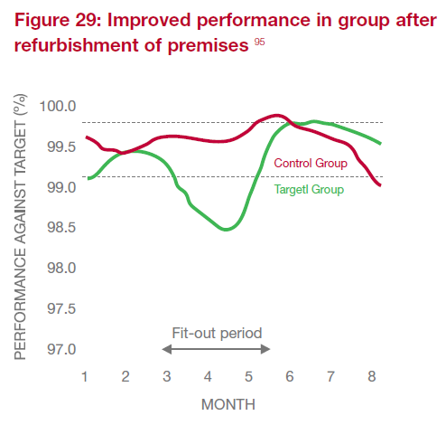
Figure 2: Improved Performance After Refurbishment

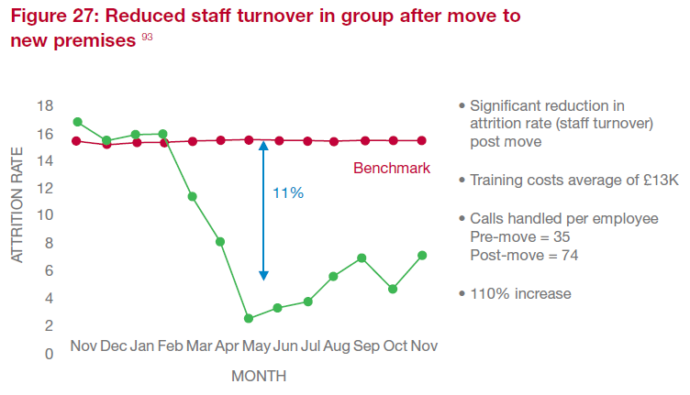
Figure 3: Reduced Staff Turnover After Move to New Premises

Research Supports Distraction-Free Offices
Salaries comprised 85% of the total costs, compared with only 8.5% for furnishing
In one landmark study of 6,000 office buildings throughout the United States during a five-year period, people costs were shown to outweigh facility costs by a ratio of 13:1 for owner-occupied buildings. As shown in Figure 4, salaries comprised 85% of the total costs, compared with only 8.5% for furnishing, maintaining and operating a facility. Therefore, senior management acknowledges that even small improvements in office worker productivity derived from FM projects are clearly worth it.

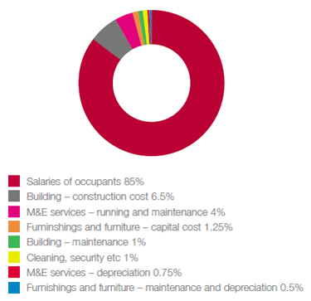
Figure 4: 25-Year Expenditure Profile Including Salary Costs
There is a near-universal need for distraction-free work
Moreover, “empirical, quantitative analyses of data from some 13,000 people in 40 business units between 1994 and 2000 concluded that one of the two most powerful design determinants of productivity and satisfaction comes from the near-universal need for distraction-free work.” This study documented how distractions and anxiety are rampant in office environments. When furnishings look old, dirty, and tired, they contribute to unnecessary distraction, which therefore decreases worker productivity.

In another FM study, a literature review was used to identify a list of 172 Key Performance Indicators. This long list was then reduced to a select 23, which were deemed to be “essential.” For the purposes of this paper, it is critical to note that Customer Satisfaction ranked #2, with Standards of Cleaning listed among the “essential 23”.

Considerations for Outsourcing Arrangements
Even outsourcers benefit by bringing in specialized service providers
Refurbishing services should invariably be performed by a specialist, whether or not FM is outsourced. One of the top three reasons that organizations choose to outsource FM services is to benefit from the expertise provided by specialist suppliers. However, even outsourcers find it necessary to engage separate specialists from time to time, which is why many advocate selecting the best-of-breed provider for each service rather than bundling services. In some cases, members of the FM service team may have some rudimentary refurbishing (aka touch-up and repair) skills. But, the vast majority of these organizations do not have the requisite expertise on staff to do it properly, because:

- Refurbishing is not core to their day-to-day jobs, and
- Refurbishing is not something they have done frequently enough to gain sufficient knowledge of best practices to perform these specialized tasks cost effectively.

Balanced Scorecard endorsement
IFMA bases its “Approach to Strategic Management” on the Balanced Scorecard
Many have advocated the use of the Balanced Scorecard for facilities performance measurement, including authors, experienced professionals, and consultants. Even the International Facilities Management Association (IFMA) bases its “Approach to Strategic Management” on the Balanced Scorecard.

“Cost is still the predominant focus of FM operations, but the industry is maturing and there is now a growing awareness of how facilities can actively support or actively disrupt the performance of people at work.”
You can’t manage what you don’t measure
In general, the Balanced Scorecard has become a widely used holistic framework that provides real insight into an organization’s operations, finances and drivers of future performance while assisting (and often guiding) overall strategy implementation. Going beyond the achievement of purely financial goals, the Balanced Scorecard encourages management to think more strategically and systemically about a range of targets and measures of business performance. The chief value of the Balanced Scorecard is to ensure that none of the four quadrants (below) either totally dominates or is entirely omitted from management’s agenda.
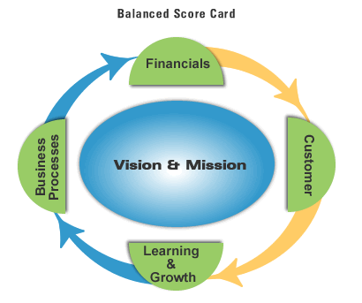
- Financial: To succeed financially, how should we appear to our shareholders?
- Internal Business Process: To satisfy our shareholders and customers, what business processes must we excel at?
- Customer: To achieve our vision, how should we appear to our customers?
- Learning and Growth: To achieve our vision, how will we sustain our ability to change and improve?

Adapted to the context of Facilities Management (FM), a suggested four-quadrant framework would be represented as follows:
Studies reveal that all four quadrants of the Balanced Scorecard, as adapted for FM, would benefit from refurbishing furnishings

- Financial: How is the FM function managed in terms of value for money?
- Internal Business Processes: How efficient and effective is the delivery of FM services?
- Customer: How do the facilities users see us?
- Learning and Growth: How does the FM function continue to improve in itself and to assist the core business?

It is difficult to clearly identify and quantify the specific financial impact that office appearance and the office environment may have on productivity. However, those firms that have deployed the Balanced Scorecard have seen a correlation across all four quadrants and clearly understand the value delivered to the long-term viability as well as the bottom line by maintaining an attractive, clean and healthy environment.

key considerations for vendor selection
When evaluating alternatives, it is critical that FM select a provider that has:

- Extensive refurbishing expertise;
- Established client base experience;
- Sustainable/Green Cleaning best practices;
- Products and processes that are odorless and approved by both EPA and OSHA.
- Sufficient resources to manage the entire project; and
- The ability to provide onsite services without disruption, either overnight or on weekends.

Sample situations where refurbishing is recommended

While all circumstances are unique to the furnishings, appearances (i.e., damage amount and severity), and location(s) to be serviced, the following lists typical situations where refurbishing most likely makes the most sense:

- Furnishings are starting to look old, dirty, and tired;
- Wood is starting to fade or dry out;
- Leather is losing suppleness, which may cause it to crack and create a situation that cannot be easily serviced; or
- Upholstered fabric is stained or soiled.
Conclusion
Before Electrostatic Painting
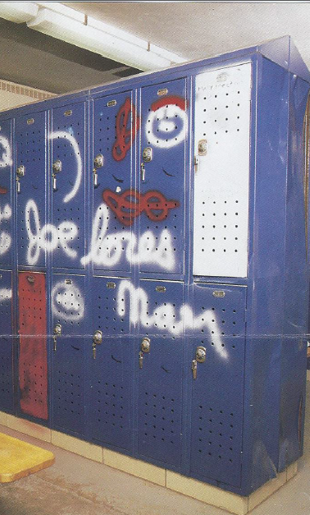
In the current climate of tight budgets and determining how to do more with less, FM teams are finding new ways to do things that increasingly add value to their organizations while keeping costs down. Numerous studies prove that productivity can be improved and absenteeism reduced by improving the internal environment. Of course user perceptions have been shown to be of perhaps greater importance than reality. So since “Perception is Reality,” FM needs to manage that perception by reaching an appropriate balance between time, cost and quality. Therefore, when it comes to furnishings, a simple and effective way to do this is by adopting a plan to evaluate Onsite Refurbishing as a form of preventative maintenance that prolongs the lifetime value of the furnishings.

The organization benefits in many ways:

- Reduced costs;
- Enforced sustainability;
- Increased productivity (and revenues);
- Improved facility appearances;
- Decreased absenteeism; and
- Extended useful life and lifetime value of furnishings.
After Electrostatic Painting
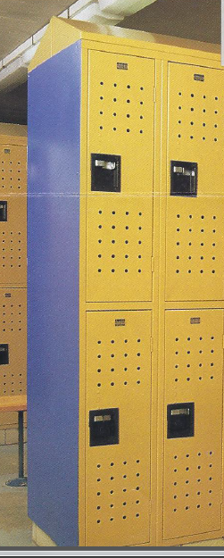
Of course, while some people choose to service their furnishings themselves, before proceeding, it would be wise to ask: Do I/we have the expertise to complete this project correctly? What’s the value of my/our time? Would it be better and more cost-effective to use specialists?

About the Author
David Ableman is VP Operations for PROTEK, a company specializing in onsite refurbishment, founded in 1963, and headquartered in Randolph, MA: www.protekcorporation.com. Mr. Ableman oversees the experienced team that has completed thousands of projects throughout the Northeast. Charged with managing Quality Control and customer expectations, Mr. Ableman is responsible for the day-to-day operations, process improvement, and Onsite, Overnight deliverables. Mr. Ableman received a BS in chemical engineering from Carnegie Mellon University in 1982 and subsequently attended Babson College for an MBA. A member of IFMA, with 30+ years of professional experience, he is an award-winning and respected consultant, speaker, trainer and author.
Connect with Dave on LinkedIn

Lydia Dishman (2014): “The Surprising Productivity Secrets Hidden in Your Clothes,” http://www.fastcompany.com.
J Sullivan (2013): “Measuring Productivity in the Office Workplace, Edition 2,” Centre for Building Performance Research.
Debra Brinegar Lister, Elisabeth M. Jenicek , Paul Frederick Preissner (1998): “Productivity and Indoor Environmental Conditions Research: An Annotated Bibliography for Facility Engineers,” US Army Corps of Engineers.
Roelofsen, P. (2002): “The impact of office environments on employee performance: the design of the workplace as a strategy for productivity enhancement.”
Carol Lomonaco and Dennis Miller, Johnson Controls, Inc. (2005) “White Paper: Environmental Satisfaction, Personal Control and the Positive Correlation to Increased Productivity.”
British Council for Offices (2004): “The impact of office design on business performance.”
British Council for Offices (2004): “The impact of office design on business performance.”
Michael Brill, et al, and the Buffalo Organization for Social and Technological Innovation (BOSTI) (1985): “Using Office Design to Increase Productivity.”
British Council for Offices (2004): “The impact of office design on business performance.”
British Council for Offices (2004): “The impact of office design on business performance.”
Michael Brill, et al, and the Buffalo Organization for Social and Technological Innovation (BOSTI) (2001): “Disproving Widespread Myths About Workplace Design.”
Andrew Smith and Michael Pitt (2006): “Facilities Management quality and user satisfaction in outsourced services.”
Falconer (2006): “The future of facilities management outsourcing.”
Amaratunga, D., et al (2000): “Assessment of facilities management performance – what next?”
WALTERS, M., (1999): “Performance measurement systems – a case study of customer satisfaction.”
International Facilities Management Association: http://www.ifma.org/about/strategic-plan/balanced-scorecard
Carter, A (2002): “Research Perspectives – The Positive effect of FM solutions on achieving corporate values.”

